Registered Report Stage 2

Mapping literature reviews on coral health: A review map, critical appraisal, and bibliometric analysis

Authors’ Contacts:

Samantha Burke1*, Patrice Pottier1, Erin L. Macartney1, Szymon M. Drobniak1,2+, Malgorzata Lagisz1+, Tracy Ainsworth3, & Shinichi Nakagawa1+

1 Evolution and Ecology Research Centre, School of Biological, Earth, and Environmental Sciences, University of New South Wales, Sydney, NSW, Australia

2 Institute of Environmental Sciences, Jagiellonian University, Kraków, Poland

3 Centre for Marine Science and Innovation, School of Biological, Earth, and Environmental Sciences, University of New South Wales, Sydney, NSW, Australia

* Corresponding author contact: Samantha Burke ([samantha.burke@unsw.edu.au](mailto:samantha.burke@unsw.edu.au))

+ Authors contributed equally to project supervision.

ORCID:

Samantha Burke <https://orcid.org/0000-0001-6902-974X>

Patrice Pottier <https://orcid.org/0000-0003-2106-6597>

Erin L. Macartney <https://orcid.org/0000-0003-3866-143X>

Szymon M. Drobniak <https://orcid.org/0000-0001-8101-6247>

Malgorzata Lagisz <https://orcid.org/0000-0002-3993-6127>

Tracy Ainsworth <https://orcid.org/0000-0001-6476-9263>

Shinichi Nakagawa <https://orcid.org/0000-0002-7765-5182>

Abstract:

1. The state of coral reefs has been of great concern, as documented in the growing amount of primary literature. These reports on coral health have accumulated, resulting in reviews of the primary studies (i.e., secondary literature). Recently, such reviews have also accumulated, creating an opportunity to review the secondary literature. Second-order syntheses (reviews of secondary literature) provide an overview of the field, which can be used to guide future research.
2. Based on our previously published protocol, we compiled peer-reviewed secondary literature on coral health from Scopus and Web of Science databases. We synthesized 335 secondary literature papers on coral health, 35 of which underwent critical appraisal and 333 of which also underwent bibliometric analysis.
3. The secondary literature consisted primarily of qualitative reviews (78%). Over 80% of papers stated informing coral conservation as the review’s purpose. Climate change (50%) and coral resilience (42%) were the most studied topics, and bioerosion was the least (3.6%). Critically appraised papers scored poorly on CEESAT criteria (studies did not meet standards 55% of the time). The authors of the secondary literature were highly-interconnected (with 30% of the authors having more than 15 coauthors within our dataset) and included authors from countries with coral reefs (predominantly in Australia and USA; 79% of papers). The secondary literature on coral health had a median Altmetric score of 5.27.
4. We have revealed key gaps in coral health topics for further review (e.g., coral range shifts and microbial biodiversity), particularly when considering conservation policy. Incorporating research in policy could be improved through greater research accessibility and continuing to gather public interest in coral reefs. We further recommend broadening research collaborations to include even more researchers from countries with coral reefs (e.g., Maldives). Finally, the secondary literature on coral health needs better reporting transparency (e.g., publishing code).
5. Our second-order synthesis is timely, pushing coral health research in a new direction - one which produces research of higher quality, collaboration, and efficiency. As coral reefs decline, we should also aim to rebuild public trust in research and strengthen the evidence base for conservation.

Keywords:

state of research, coral recovery, research mapping, coral disease, coral bleaching, critical assessment, research weaving, literature synthesis, systematic review

Introduction:

Coral reefs support approximately 25% of marine species and are integral to coastal economies by supporting industries such as fishing and tourism (Bowen et al., 2013; Cesar and van Beukering, 2004; Plaisance et al., 2011). However, these key ecosystems are declining globally. Thus, coral reefs have been extensively studied to ensure their conservation (e.g., Erftemeijer et al., 2012; Frank and Mokady, 2002; Hoegh-Guldberg O. et al., 2007; Vega Thurber et al., 2020). Therefore, empirical studies on coral reefs (the primary literature) have been rapidly accumulating, stimulating in turn a growing volume of reviews and syntheses (the secondary literature). We have currently reached a stage when the number and comprehensiveness of available secondary literature enables a meaningful second-order synthesis to be undertaken so the research can be understood easily (Burke et al., 2022).

Second-order synthesis, a compilation of relevant reviews, can be accomplished through techniques collectively referred to as ‘research weaving’: a combined use of systematic mapping and bibliometric analyses (Hofmeyr and Cochrane Collaboration, 2008; Ioannidis, 2009; Nakagawa et al., 2019). Systematic maps report the state of knowledge within a field, identifying research gaps, most studied themes, and timelines of when topics gained popularity. Also, such maps could include assessments of the quality of studies mapped (i.e., critical appraisal; Woodcock et al., 2014). On the other hand, bibliometric analyses visualize publication and author details, which can be used to identify biases within the field. Through citation information and alternative metrics of impact, bibliometric maps also give a sense of a field’s reach within and outside of academia (e.g., conservation practice and policymaking). Overviews and insights gained from systematic maps and bibliometric analyses help not only to shape future research directions but also to create appropriate management plans and conservation policies.

Here, we conduct a second-order synthesis (analysis of review literature) on coral health research using systematic mapping, critical appraisal, and bibliometric analyses. Such synthesis is particularly timely because coral reefs are at the final turning point before collapse (Obura et al., 2021; Tebbett et al., 2021). By mapping the state of the research on coral health, we hope researchers will be able to identify future research topics and collaborate with necessary parties. We aimed to answer the following questions, as outlined in our protocol (Burke et al., 2022):

* What types of reviews are used most (e.g., narrative, systematic reviews, or meta-analyses)?
* What are the common and newly emerging topics?
* How robust (e.g., quality of reporting) are the available systematic reviews?
* How are the collaboration networks structured?
* Which countries do review authors come from?
* What type of journals (i.e., specialized or interdisciplinary) do reviews of coral health get published in?

# Materials and Methods:

## Reporting

We followed the methods outlined in our protocol (Burke et al., 2022) apart from the minor deviations and additions described in the section *Deviations, Additions, and Justifications*. We follow MeRIT guidelines to report author contributions (Nakagawa et al., 2023). SB used the search string in our protocol for both Scopus and Web of Science databases and found 2,909 papers and 2,646 papers, respectively. Altogether, SB and PP independently screened 3,472 unique papers using our previously outlined inclusion criteria (Burke et al., 2022). This yielded a total of 335 papers included for data extraction and 3,137 papers excluded by subject matter or study type identified in the title, abstract, and keywords (Figure 1). To be included for analysis, studies must have focused on reviewing an aspect of coral health. That is, at least half of a paper’s topics must have been related to the health of corals. Examples of excluded papers are provided in supplementary materials (Table S1).

SB and PP extracted data for the systematic map as laid out in the protocol (Burke et al., 2022). SB and PP looked for key factors within the abstract, title, and keywords of the included papers. These 29 key factors are composed not only of topics of papers (e.g., coral disease, coral bleaching, etc.) but also other aspects such as methodology (e.g., remote sensing; Table S2). These 29 extracted factors are simplified into a single joining term (as described in our protocol) but included related phrases and concepts. Thus, we refer to these extracted factors as “terms.” For ease of reporting, we grouped the terms into three sections as described in the protocol: approach and purpose, drivers of change in coral health, and coral health outcomes.

When assessing study type, SB and PP took note of papers which self-identified as any type of “systematic-like review.” These “systematic-like review” papers consisted of literature syntheses such as systematic reviews, meta-analyses, and systematic maps (defined in Burke et al., 2022). We aimed to analyse these papers separately as these types of reviews are expected to be conducted with a particular level of reproducibility and are relatively new to marine ecology research.

## Deviations, Additions, and Justifications

During the data extraction from each paper’s abstract, title, and keywords, SB and PP found 41 additional relevant review topic-related terms we had not set a priori in the protocol. They all seemed to be major themes of coral health reviews, and thus were included for analysis. For ease of visualization alone (Figure S1A), we grouped these terms into four categories: 1) biochemical responses (“bioaccumulation,” “chlorophyll,” “functional gene,” “genetic,” “genetic response,” “immune response,” “metabolism,” “photobiology,” “photosynthesis,” “pigmentation,” “productivity,” “respiration,” and “signaling molecules”), 2) biophysical drivers (“accretion,” “depth,” “salinity,” “sea level,” “water flow,” and “wind”), 3) reef-scale processes (“aging,” “algae,” “competition,” “connectivity,” “growth,” “herbivory,” “hybridization,” “interaction,” “phase shift,” “recruitment,” “reproduction,” “succession,” and “transmission”), and 4) others (“aquaculture,” “captivity,” “evolution,” “feedback loop,” “life history,” “marine protected area”, “physiology,” “science communication,” and “soft coral”) based arbitrarily on perceived intent from the paper. We kept these terms separate from those we set out to investigate in the protocol because they were not widely identified across papers. We include them in the supplement to best reflect the state of knowledge in the secondary literature on coral health (Figure S1).

We originally planned to extract bibliometric data for all papers from Scopus (for the rationale for the use of Scopus, see Burke et al., 2022). However, SB was unable to find two of the included papers in the Scopus database. These two papers (Bove et al., 2020; Frank and Mokady, 2002) were thus left out from the bibliometric analysis.

All figures were created using R version 4.2.2 (R Core Team, 2021; RStudio Team, 2021). Several packages were used to create the figures including *ggplot2* (version 3.4.0, Wickham, 2016), *maps* (version 3.4.1, Becker et al., 2022), *bibliometrix* (version 4.1.0, Aria and Cuccurullo, 2017), *circlize* (version 0.4.15, Gu et al., 2014), *tm* (version 0.7-11, Feinerer et al., 2008), and *wordcloud* (version 2.6, Fellows, 2018).

Results:

Data Characteristics

From the 3,472 papers screened, 335 papers matched our inclusion criteria (Figure 1). 335 papers provided data for the systematic map, while 333 papers provided data for the bibliometric analysis. SB and PP also identified 35 papers that self-reported as any type of systematic review. SB and PP were then able to conduct a critical appraisal of these papers using the CEESAT critical assessment (Woodcock et al., 2014) and assessed the presence of data and code in the systematic-like reviews on coral health.

Systematic Map

*Approach and Purpose*

Most reviews on coral health were narrative reviews (77.8%, 298 papers; Figure 2A). Systematic-like reviews made up just over 10% (35 papers) of the papers collected, most of which were meta-analyses (6.53% of papers collected, 25 papers; Figure 2A). Of the papers examined, 84.6% (280 papers) reported their purpose for the review as summarising evidence for reef conservation and management (Figure 2B) and one third (32.3%, 107 papers) reviewed methods (e.g., for collecting data and conducting research on coral health) (Figure 2B). While 14.2% (47 papers) of papers incorporated quantitative analyses (Figure 2B), 11.0% (42 papers) of papers self-identified as a “quantitative synthesis” (Figure 2A). Few studies used (either as a part of the analysis or evaluating effectiveness) remote sensing data (5.14%, 17 papers; Figure 2B). The first of the investigated terms to be published in coral health secondary literature was “conservation” (first appeared in 1994; Figure S2). The term “quantitative synthesis” first appeared most recently (2002; Figure S2).

Within the systematic-like literature, “conservation” and “quantitative synthesis” were equally most common (68.6%, 24 papers; Figure S3A). The term “remote sensing” was not found in the systematic-like coral health literature (Figure S3A).

*Drivers of change in coral health*

Of all the drivers of coral reef health examined in our survey, we found the broad term “climate change” most often investigated in the collated literature (50.5% of papers, 167 papers; Figure 3A). Two other broad terms were also often found: microbiome (31.4%, 104 papers) and symbiosis (29.0%, 96 papers; Figure 3A). We found the broad term “anthropogenic impacts” in 27.8% (92 papers) of the papers examined (Figure 3A). Of the commonly identified climate change impacts in the marine environment, the most studied driver of coral health condition was “increased sea surface temperature (SST)” (33.8% of papers, 112 papers), and bioerosion was the least (3.63%, 12 papers; Figure 3A). Of the commonly identified human impacts on the marine environment, “pollution” (both chemical – 23.6%, 78 papers - and non-chemical – 22.1%, 73 papers) was highly studied, and “physical damage from humans” (9.37%, 31 papers) was relatively understudied (Figure 3A). Of the 17 terms examined, we identified 12 of them in less than 25% of papers (Figure 3A). The driver term that appeared in coral health secondary literature the earliest was “physical damage caused by humans” (studied since 1994; Figure S2B). The term “calcification” appeared most recently (2021; Figure S2B).

When examining only the systematic-like secondary coral health literature, we saw “climate change” was still the most prevalent (48.6%, 17 papers) followed by “increased SST” (37.1%, 13 papers; Figure S3B). However, “anthropogenic impacts” alongside “calcification” were the third most common (17.1%, 6 papers each), and the impacts of predators and bioerosion were the least common (2.86%, 1 paper each; Figure S3B). We did not find the terms “habitat range shifts” and “physical damage caused by humans” within the collated systematic-like literature (Figure S3B).

*Coral health outcomes*

The most common outcome reviewed in the coral health literature was “coral resilience” (42.3% of papers, 140 papers), followed by “bleaching” (38.4%, 127 papers) and “coral/coral reef recovery” (27.2%, 90 papers; Figure 3B). Few studies examined the impacts upon microbial biodiversity within a coral (16.3%, 54 papers; Figure 3B). Coral mortality rates (24.2%, 80 papers), coral biodiversity within a reef (23.0%, 76 papers), and coral disease (21.5%, 71 papers) were also the focus of less than 25% of coral health secondary literature (Figure 3B). The outcome explored over the longest period of time in coral health secondary literature was “coral mortality” (since 1995), while the newest outcome explored was “microbiome biodiversity” (2009; Figure S2C).

The outcomes examined in systematic-like coral health literature closely mirrored those of all the coral health secondary literature. The most common outcome term among systematic reviews was “coral resilience” (42.9%, 15 papers), with the term “coral mortality” found second-most often (37.1%, 13 papers). The least common terms included “reef biodiversity” (17.1%, 6 papers), “disease” (8.57%, 3 papers), and “microbiome biodiversity” (8.57%, 3 papers) (Figure S3C).

## Bibliometric Map

The keywords of coral health secondary literature reflect the information from the systematic map. Besides “coral(s)” and “reef(s)”, “climate change”, “bleaching”, and “disease” appeared most often in the coral health secondary literature keywords (Figure S4). Other common keywords included “management”, “symbiosis”, “resilience”, and “restoration” (Figure S4).

First author affiliations from the coral health secondary literature predominantly included countries from the Global North, in particular the United States of America, Australia, and the United Kingdom (Figure 4A, S5). Authors of coral health secondary literature, in general, commonly affiliated with countries that have coral reefs within their territory (63.04% of all countries producing coral health reviews; 79.4% of reviews). There was a great degree of collaboration between affiliated countries (64% of collaborations were international; Figure 4B). Co-authorship network of individual authors contained one large dominating cluster of connected authors who collaborated on review publications (e.g., 103 out of 1,190 authors have more than 50 collaborations each, 355 out of 1,190 authors have more than 15 collaborations each; Figure 5). However, smaller, isolated clusters of authors were also common (Figure S6).

Coral health reviews increased in frequency around 2010 before decreasing around 2015 (Figure 7A). In 2017, coral health reviews spiked once again and appeared to continue their upward trajectory until the end of our examined period (Figure 7A). Coral health review literature published in the early 2000s understandably had the greatest number of citations per article, with two papers from 2003 (Hughes et al.) and 2007 (Hoegh-Guldberg O. et al.) each cited over 2,500 times (Figure 7B). However, generally, coral health secondary literature was much less cited (median: 33, mode = 1; Figure 7B).

Most coral health reviews were published in broader subject area journals rather than in journals that focused on one particular subject (Figure 7A). The most common subject categories for the journals in which coral health reviews were published included Aquatic Science, Ecology, Evolution, Behavior and Systematics, Ecology, Oceanography, and Environmental Science (Figure 7B). However, three journals stood out as the journals in which coral health reviews were most often published, all of which were marine-focused journals: Coral Reefs (2021 Impact Factor: 4.640; Clarivate; 2021 *h*-Index: 114; Scimago), Frontiers in Marine Science (2021 Impact Factor: 5.247; Clarivate; 2021 *h*-Index: 68; Scimago), and Marine Pollution Bulletin (2021 Impact Factor: 7.001; Clarivate; 2021 *h*-Index: 193; Scimago; Figure 7C). On average, the journals in which researchers published coral reef secondary literature had an impact factor of 8.07 (median = 4.65, range = 0.150 – 78.3) and an *h*-Index of 162.8 (median = 114, range = 6 – 1229).

Alternative metrics of impact (Altmetric scores; Priem, 2015; Robinson-García et al., 2014) revealed a wide range of social media and policy impacts of coral health secondary literature via many measures (Table S3). The overall Altmetric score, which encompasses the total reach of a paper to all measured alternative impact mediums, reached a maximum of 1234.892 in one paper (Van Oppen et al., 2015), with the average paper receiving an Altmetric score of 35.19 (median = 5.27, range = 0.25 – 1234.9; Figure 8A, Table S3, S4). The secondary literature on coral health we collected was cited in policy 0.565 times on average (median = 0, range = 0 – 21; Figure 8B, Table S3, S4). The paper by Hoegh-Guldberg was cited in policies 21 times (2007), with the next most cited paper being cited in 10 policies (Hughes et al., 2003; Figure 8B). The secondary literature we examined was rarely mentioned in patents (an average of 0.0115 patents cited any of the included literature, median = 0, range = 0 - 2; Figure 8C, Table S3, S4). Only two papers were cited in any patents, with one cited twice (Mumby et al., 2004) and the other cited in only one patent (De Valck and Rolfe, 2019; Figure 8C).

Mainstream news outlets were more likely to refer to coral health-related secondary literature than patents or policies (Figure 8D). A single study was mentioned by news outlets 145 times (Van Oppen et al., 2015), but, on average, coral health secondary literature was found in 2.10 news references (median = 0, range = 0 – 145; Figure 8D, Table S3, S4). On Wikipedia, where much of the general public starts their search for information, the included coral health secondary literature was referenced 0.581 times on average, with a single paper (Hoegh-Guldberg O. et al., 2007) cited 25 times median = 0, range = 0 – 25; Figure 8E, Table S3, S4). With researchers so prevalent on Twitter, we found more mentions of coral health secondary literature in tweets. A single paper was tweeted by as many as 212 Twitter users (Bostrom-Einarsson et al., 2020), while the average paper was tweeted by 17.76 users (median = 2, range = 0 – 212; Figure 8F, Table S3, S4).

## Critical Appraisal

‘Systematic-like reviews’ on coral health often did not meet the standards set out by the Collaboration for Environmental Evidence Synthesis Assessment Tool (CEESAT; Woodcock et al., 2014). On average, for each question, a paper received a green score (i.e., met the criteria for transparency and rigour) 27.47% of the time, an amber score (i.e., met some of the criteria for transparency and rigour, but was missing some key elements) 18.02% of the time, and a red score (i.e., did not meet the criteria for transparency and rigour, or was missing too many key components that would impact the ability to replicate or interpret the findings) 54.51% of the time (Figure 9A).

Systematic-like reviews on coral health performed the worst (i.e., most papers scored red) on questions one, five, and six in the CEESAT questionnaire (Figure 9A). As such, systematic-like reviews of coral health often did not have protocols set *a priori*, did not provide the information necessary for a reproducible literature inclusion / exclusion process, and did not report their inclusion and exclusion decisions in detail. However, the systematic-like literature examined performed the best (i.e., most papers scored green) on questions four and eleven (Figure 9A). Thus, these reviews often clearly documented their inclusion criteria and conducted a quantitative analysis such as meta-analysis. Additionally, to supplement reproducibility, more than half (57.14%) of the systematic-like coral health reviews provided the data analyzed in the review (Figure 9B). On the other hand, the code used to analyze the data was provided by only 17.14% of systematic-like coral health reviews, all of which were published in the past five years (Figure 9B, S7C).

## Additional Exploratory Analyses

While extracting terms using the Google Form described in our protocol (Burke et al., 2022), we identified some terms we had not originally included in the form that seemed to be common and important aspects of coral health secondary literature (as described in Materials and Methods above). Of these, the most common term we noted was “reproduction,” which appeared in 6.87% of papers (23 papers; Figure S1B), followed by “Marine Protected Areas” and similar terms (e.g., Marine Park, Protected Zone, etc.; 5.37%, 18 papers), “phase shift” from one type of organism dominating the ecosystem to another (4.48%, 15 papers), and coral “metabolism” (3.28%, 11 papers; Figure S1B). Terms related to reef-scale processes make up the majority of these added terms and are found in 14.9% of all papers found (Figure S1A). Terms describing biochemical responses follow closely in abundance (8.96% of all papers), and the least explored terms pertained to biophysical drivers (1.79% of all papers; Figure S1A).

Discussion

We conducted the first second-order synthesis of coral health literature by weaving together information from relevant reviews and bibliometric data. Overall, our systematic map revealed that topics relating to “conservation” were reviewed the most (Figure 2B), followed by “climate change” (Figure 3A) and “coral resilience” (Figure 3B). Topics such as “remote sensing” (Figure 2B), “range shift” (Figure 3A), and “bioerosion” (Figure 3A) were found to be underrepresented among reviews. We also identified through bibliometric analysis that coral health secondary literature is mainly conducted by a network of authors from countries in the Global North (Figure 4, S5). Few coral health reviews had a reach outside of academia (Figure 8). Systematic-like reviews of coral health were lacking in transparency, as set by CEESAT standards, and rarely provided data and code (Figure 9; Woodcock et al., 2014). Below, we discuss each of the three analyses (systematic mapping, bibliometric analysis, and critical appraisal) in turn to further address our *a-priori* questions.

Systematic Mapping

Types of coral health reviews

We found that a large proportion of researchers published narrative reviews while few conducted quantitative analyses (Figure 2A). While narrative reviews of research findings help push the field forward, there are ways to evaluate findings in a more systematic and unbiased manner when applicable to the data (e.g., there is ample data on the subject). For example, meta-analyses, which use empirical data to quantify a particular trend or comparative feature (e.g., Crouzeilles et al., 2016; Gurevitch et al., 2018; Pottier et al., 2021; Shafer and Wolf, 2013), are rare in the coral health secondary literature (Figure 2A). Similarly, our collection of coral health secondary literature only contained one study that conducted a “critical review” of the primary literature (Figure 2A; Brodie and Waterhouse, 2012). Critical reviews evaluate study quality in terms of factors such as publication transparency and research rigour (Tod et al., 2022). Therefore, opportunities exist for future reviews to incorporate quantitative analysis and systematic research methods more widely as well as to critically review the literature in the field.

Many coral health reviews intend to inform conservation efforts (Figure 2B). However, research rarely evaluated the methodologies of primary studies (i.e., methodology reviews; Figure 2B), which is important given the heterogeneity of sampling methods (Burke et al., 2023). Reviews of methodology can improve efficiency in data collection, making research cheaper, more effective, and, hopefully, more accessible. Of relevance, remote sensing has become a popular method of collecting some data for coral health evaluations due to its accessibility (Hedley et al., 2016; Hochberg, 2011; Knudby et al., 2007; Mumby et al., 2004; Purkis, 2018). However, we did not see this reflected in the review-level literature (e.g., studies validating the accuracy of analyses using remote sensing data; Figure 2B), despite finding that the first reviews of remote sensing data in our collection were published in 2000 (Figure S2A; Dustan et al., 2000; Spencer et al., 2000). It should be noted that we excluded many remote sensing studies because they did not mainly focus on coral health as we set in our inclusion / exclusion criteria. Currently remote sensing studies are used to analyse non-health-related data such as coral cover, which, while useful for research and could later be applied to coral health studies, was not captured by our inclusion criteria. Remote sensing techniques are due for a systematic review or map.

Commonly reviewed topics

We found the broad terms “climate change,” “anthropogenic impacts,” and “resilience” in much of the coral health secondary literature (Figure 3A). More specific terms did not follow such a trend, with terms like “increased sea surface temperature (SST)” and “bleaching” occurring often and terms like “habitat range shift” appearing most rarely (Figure 3). Furthering research efforts on these neglected topics could reveal some key insights into coral reefs’ ability to survive. Three topics are worth expanding upon.

First, while we saw many papers which reviewed the evidence on microbes that make up the coral holobiont (Figure 3A), we saw few papers which discussed how the diversity of the microbial community plays a role in healthy coral function (e.g., the interactions among holobiont microbes and how that can affect immune responses). As microbes each provide different functions (e.g., immune response, food production through photosynthesis, etc.) within the coral holobiont (Ainsworth et al., 2017; Ricci et al., 2019), the studies of interaction among microbes require a systematic review or map.

Second, as corals are sessile, slow-growing animals, the lack of reviews exploring coral habitat range shifts is understandable. Yet, the habitat ranges of other organisms can directly or indirectly affect corals (e.g., crown-of-thorns starfish, damselfishes, etc.). This interaction ties closely to other factors explored in our synthesis (e.g., disease and predation; Casey et al., 2014; Deaker and Byrne, 2022; Renzi et al., 2022). We believe it is possible to quantitatively review the extent of range shifts in corals. As some coral species appear more tolerant to environmental stressors (e.g., heat stress; Yakob and Mumby, 2011), surveys identifying coral species in new regions are emerging (e.g., Adam et al., 2021) and could be reviewed more widely and on a global scale.

Third, the topic of bleaching is reviewed extensively in coral health secondary literature, but coral disease reviews are rarer (Figure 3B). Despite abundant records of coral disease worldwide (e.g., Burke et al., 2023)(Aeby et al., 2021; Ruiz-Moreno et al., 2012; Sabdono et al., 2014; Wijayanti et al., 2016), disease research is rarely compiled to identify broader trends. Our previous work linked disease surveys to sea surface temperature (SST) records to quantify the influence of ocean warming on coral disease prevalence (Burke et al., 2023). However, ocean warming is just one of many potential drivers of coral disease. Factors such as human damage, pollution, and cyclones were found to correlate with coral disease, but on more local scales (Erftemeijer et al., 2012; Lamb et al., 2014; Wolff et al., 2016). However, global reviews of trends in coral disease appear to be scarce. We thus revealed an opportunity to expand the scale of coral disease research through quantitative and qualitative reviews of the empirical data.

Bibliometric Analyses

Collaboration networks

While most authors of second-order literature on coral health are well-connected and collaborative, there are still many satellite groups of authors that exist outside this main network (Figure 4C). When examining where the authors of reviews are based, we found that there is a strong bias towards the United States and Australia (Figure 4A). These two countries are home to large coral reef ecosystems (e.g., Hawaiian reefs, some Caribbean reefs, Great Barrier Reef), although other countries which have large reefs (e.g., Philippines, Indonesia, and Fiji all contribute to nearly half of the world’s coral reefs alongside Australia, Papua New Guinea, and the Maldives; Spalding et al., 2001) are underrepresented in both the literature and author networks. Increasing collaboration with countries of the Global South will ensure all reefs receive research attention for conservation and local researchers are involved in evidence synthesis efforts (Adame, 2021; Thambinathan and Kinsella, 2021).

Academic, media, and policy impacts

The coral health secondary literature often cited conservation and management as a reason for conducting the review (Figure 2B). This reported purpose hinted that the intended audience was the broader community (e.g., policymakers and practitioners who will use the evidence to plan or enact conservation measures). Yet, we found the number of citations by policy documents was low (Figure 8B, Table S3, S4). Indeed, the disconnect between policy and research output is recognized in various fields (Abbas and Kakkar, 2013; Buckley et al., 1998; Cook et al., 2013a, 2013b; Crain-Dorough and Elder, 2021; Freshwater and Trapasso, 2014). Review findings may be too broad to be applied to specific locations or the challenges within them, or too technical for non-academics to digest (Buckley et al., 1998). Or perhaps the research itself is hard to find (Buckley et al., 1998). Indeed, most of the collected coral health secondary literature was published in journals with a general subject area (i.e., not dedicated to a single subject; Figure 7A).

Policy citation for coral health literature is further complicated by the policy process. Environmental policy implementation is highly intricate and often reactive to sudden natural disasters (Benson and Jordan, 2015). As the gradual decline of coral health can be hard to see for the average land-living citizen, we may not yet have built up enough concern to spark widespread policy creation advised by research. Thus, we highlight the importance of making reviews of evidence more digestible and applicable for a wider audience to garner greater attention and advocacy.

Despite the above, Altmetric data highlight how two papers (Hoegh-Guldberg O. et al., 2007; Van Oppen et al., 2015) hold the highest values in 8 out of 14 Altmetric measures (Table S4). It is encouraging that these two reviews which broke out in the public eye hold high interest overall (Figure 8). Making secondary research more noticeable outside academia remains a challenge, but we may see another spark in public interest and awareness as academic literature continues to expand.

Critical Appraisal

Systematic-like reviews on coral health appear to be of a lower quality than the standard set forth by Woodcock et al. (2014) because most of the quality scores were marked as inadequate. This result can be explained by systematic-like reviews being relatively new to marine science. However, expectations for research transparency and rigor are higher now than ever before. Studies not meeting the standard could go unpublished because many journals have recently adopted more explicit reporting guidelines (Andriuzzi, 2022; Chambers, 2019; Chambers and Tzavella, 2021; Nature Communications Editorial, 2022). Even if published, the lack of rigour and transparency could create greater scrutiny as to the validity of the results.

Upon conducting this critical appraisal, we realized the CEESAT criteria may not be the best tool for evaluation, particularly for non-quantitative reviews. At least four out of the 13 CEESAT criteria explicitly refer to a quantitative analysis as a requirement for the highest score. Additionally, we cannot separate reporting from conduct. That is, low scores may be due to a lack of transparency in the reporting and not due to a lack of testing or rigor in analysis. As the field continues to progress, there are steps researchers can take to improve transparency. For systematic reviews, systematic mapping, and meta-analyses, we recommend reporting guidelines, such as PRISMA-EcoEvo (O’Dea et al., 2021) and ROSES (Haddaway et al., 2018), which explicitly state what information to report in which sections. Additionally, these guidelines recommend reviews to publicly provide data and code, where available. We already see reporting of data on the rise, and we hope that code reporting will follow suit (Figure S7).

Conclusion

Secondary literature on coral health currently focuses on climate change and coral/coral reef resilience with the intention of aiding conservation efforts. We found key research gaps in the field, particularly with respect to the influence of both coral microbial communities and physical damage on coral health. While there is much more to explore in coral health, the field needs better ways to reach the intended audiences particularly where the intended goals are to inform policy and conservation practices. Additionally, researchers from more diverse regions, particularly those with coral reefs and coral reef management agencies, need far greater inclusion in coral health secondary literature. Lastly, greater transparency and uniformity in reporting will only elevate trust in findings and the usability of research reviews. We hope that by calling attention to the state of knowledge and connective networks in coral health research, future research efforts can become more targeted, efficient, and collaborative.

Author Contributions

Samantha Burke, Shinichi Nakagawa, Patrice Pottier, and Malgorzata Lagisz conceptualized the idea for this study. Samantha Burke, Shinichi Nakagawa, Patrice Pottier, Malgorzata Lagisz, and Erin L Macartney designed the methods, and Tracy Ainsworth validated the design. Samantha Burke and Patrice Pottier screened the papers found by the search string. Malgorzata Lagisz validated the paper screening process. Samantha Burke, Patrice Pottier, and Malgorzata Lagisz extracted the data needed for analysis. Data analysis was conducted by Samantha Burke, Shinichi Nakagawa, Szymon M Drobniak, and Malgorzata Lagisz. Samantha Burke led the writing of the manuscript with crucial contributions from Shinichi Nakagawa, Malgorzata Lagisz, and Tracy Ainsworth. All authors edited the manuscript in a meaningful manner. Samantha Burke created all figures, and Malgorzata Lagisz, Szymon M Drobniak, Erin L Macartney, and Shinichi Nakagawa all contributed to their designs. Shinichi Nakagawa, Tracy Ainsworth, Malgorzata Lagisz, and Szymon M Drobniak supervised the project. All authors give their approval for the publication of this manuscript in its final form.

Acknowledgements

Samantha Burke and Patrice Pottier recognize the support provided by the UNSW Scientia Doctoral Scholarship. Szymon M Drobniak is supported by the ARC Discovery Early Career Award (DE180100202). Shinichi Nakagawa, Malgorzata Lagisz, and Erin L Macartney acknowledge the financial support of the ARC Discovery grant (DP200100367).

Conflict of Interest

Review authors have no competing interests to declare.

Data Availability Statement

Data Availability

Datasets are available in a GitHub Repository (https://github.com/sburke-unsw/CoralHealthSecondOrderSynthesis) and a Zenodo open repository (DOI: 10.5281/zenodo.8365306). Extracted data is stored as .csv files and .rds files and its meta-data is provided as a .csv file. Bibliometric data is available as .bib files and a .rds file.

Code Availability

Code is available in a GitHub repository (https://github.com/sburke-unsw/CoralHealthSecondOrderSynthesis) and a Zenodo open repository (DOI: 10.5281/zenodo.8365306) as a .Rmd file. We also provide the code in html format.

References

Abbas, S.S., Kakkar, M., 2013. Research & policy disconnect: The case of rabies research in India. Indian J. Med. Res. 138.

Adam, A.A.S., Garcia, R.A., Galaiduk, R., Tomlinson, S., Radford, B., Thomas, L., Richards, Z.T., 2021. Diminishing potential for tropical reefs to function as coral diversity strongholds under climate change conditions. Divers. Distrib. 27, 2245–2261. https://doi.org/10.1111/ddi.13400

Adame, F., 2021. Meaningful collaborations can end ‘helicopter research.’ Nature d41586-021-01795–1. https://doi.org/10.1038/d41586-021-01795-1

Aeby, G.S., Shore, A., Jensen, T., Ziegler, M., Work, T., Voolstra, C.R., 2021. A comparative baseline of coral disease in three regions along the Saudi Arabian coast of the central Red Sea. PLOS ONE 16, e0246854. https://doi.org/10.1371/journal.pone.0246854

Ainsworth, T.D., Fordyce, A.J., Camp, E.F., 2017. The Other Microeukaryotes of the Coral Reef Microbiome. Trends Microbiol. 25, 980–991. https://doi.org/10.1016/j.tim.2017.06.007

Andriuzzi, W., 2022. Opportunities and challenges for Registered Reports in ecology and evolution. Nat. Commun. 13, 7266. https://doi.org/10.1038/s41467-022-32900-1

Aria, M., Cuccurullo, C., 2017. bibliometrix: An R-tool for comprehensive science mapping analysis. J. Informetr. 11, 959–975. https://doi.org/10.1016/j.joi.2017.08.007

Becker, R.A., Wilks, A.R., Brownrigg, R., 2022. maps: Draw Geographical Maps.

Benson, D., Jordan, A., 2015. Environmental Policy: Protection and Regulation, in: International Encyclopedia of the Social & Behavioral Sciences. Elsevier, pp. 778–783. https://doi.org/10.1016/B978-0-08-097086-8.91014-6

Bostrom-Einarsson, L., Babcock, R.C., Bayraktarov, E., Ceccarelli, D., Cook, N., Ferse, S.C.A., Hancock, B., Harrison, P., Hein, M., Shaver, E., Smith, A., Suggett, D., Stewart-Sinclair, P.J., Vardi, T., McLeod, I.M., 2020. Coral restoration - A systematic review of current methods, successes, failures and future directions. PLOS ONE. https://doi.org/10.1371/journal.pone.0226631

Bove, C., Umbanhowar, J., Castillo, K., 2020. Meta-Analysis Reveals Reduced Coral Calcification Under Projected Ocean Warming but Not Under Acidification Across the Caribbean Sea. Front. Mar. Sci. 7. https://doi.org/10.3389/fmars.2020.00127

Bowen, B.W., Rocha, L.A., Toonen, R.J., Karl, S.A., 2013. The origins of tropical marine biodiversity. Trends Ecol. Evol. 28, 359–366. https://doi.org/10.1016/j.tree.2013.01.018

Brodie, J., Waterhouse, J., 2012. A critical review of environmental management of the “not so Great” Barrier Reef. Estuar. Coast. Shelf Sci. 104–105, 1–22. https://doi.org/10.1016/j.ecss.2012.03.012

Buckley, M.R., Ferris, G.R., Bernardin, H.J., Harvey, M.G., 1998. The disconnect between the science and practice of management. Bus. Horiz. 41, 31–38. https://doi.org/10.1016/S0007-6813(98)90032-5

Burke, S., Pottier, P., Macartney, E.L., Drobniak, S.M., Lagisz, M., Ainsworth, T., Nakagawa, S., 2022. Mapping literature reviews on coral health: Protocol for a review map, critical appraisal and bibliometric analysis. Ecol. Solut. Evid. 3. https://doi.org/10.1002/2688-8319.12190

Casey, J.M., Ainsworth, T.D., Choat, J.H., Connolly, S.R., 2014. Farming behaviour of reef fishes increases the prevalence of coral disease associated microbes and black band disease. Proc. R. Soc. B Biol. Sci. 281, 20141032. https://doi.org/10.1098/rspb.2014.1032

Cesar, H.S.J., van Beukering, P.J.H., 2004. Economic valuation of the coral reefs of Hawai’i (1). Pac. Sci. 58, 231+.

Chambers, C., 2019. What’s next for Registered Reports? Nature 573, 187–189. https://doi.org/10.1038/d41586-019-02674-6

Chambers, C.D., Tzavella, L., 2021. The past, present and future of Registered Reports. Nat. Hum. Behav. 6, 29–42. https://doi.org/10.1038/s41562-021-01193-7

Cook, C.N., Mascia, M.B., Schwartz, M.W., Possingham, H.P., Fuller, R.A., 2013a. Achieving Conservation Science that Bridges the Knowledge–Action Boundary. Conserv. Biol. 27, 669–678. https://doi.org/10.1111/cobi.12050

Cook, C.N., Possingham, H.P., Fuller, R.A., 2013b. Contribution of Systematic Reviews to Management Decisions. Conserv. Biol. 27, 902–915. https://doi.org/10.1111/cobi.12114

Crain-Dorough, M., Elder, A.C., 2021. Absorptive Capacity as a Means of Understanding and Addressing the Disconnects Between Research and Practice. Rev. Res. Educ. 45, 67–100. https://doi.org/10.3102/0091732X21990614

Crouzeilles, R., Curran, M., Ferreira, M.S., Lindenmayer, D.B., Grelle, C.E.V., Rey Benayas, J.M., 2016. A global meta-analysis on the ecological drivers of forest restoration success. Nat. Commun. 7, 11666. https://doi.org/10.1038/ncomms11666

De Valck, J., Rolfe, J., 2019. Comparing biodiversity valuation approaches for the sustainable management of the Great Barrier Reef, Australia. Ecosyst. Serv. 35, 23–31. https://doi.org/10.1016/j.ecoser.2018.11.003

Deaker, D.J., Byrne, M., 2022. Crown of thorns starfish life-history traits contribute to outbreaks, a continuing concern for coral reefs. Emerg. Top. Life Sci. 6, 67–79. https://doi.org/10.1042/ETLS20210239

Dustan, P., Chakrabarti, S., Alling, A., 2000. Mapping and monitoring the health and vitality of coral reefs from satellite: a biospheric approach. Life Support Biosphere Sci. Int. J. Earth Space 7, 149–159.

Erftemeijer, P.L.A., Riegl, B., Hoeksema, B.W., Todd, P.A., 2012. Environmental impacts of dredging and other sediment disturbances on corals: A review. Mar. Pollut. Bull. 64, 1737–1765. https://doi.org/10.1016/j.marpolbul.2012.05.008

Frank, U., Mokady, O., 2002. Coral biodiversity and evolution: recent molecular contributions. Can. J. Zool. 80, 1723–1734. https://doi.org/10.1139/Z02-131

Freshwater, D., Trapasso, R., 2014. The Disconnect Between Principles and Practice: Rural Policy Reviews of OECD Countries: The Disconnect Between Principles and Practice. Growth Change 45, 477–498. https://doi.org/10.1111/grow.12059

Gu, Z., Gu, L., Eils, R., Schlesner, M., Brors, B., 2014. circlize implements and enhances circular visualization in R. Bioinformatics 30, 2811–2812.

Gurevitch, J., Koricheva, J., Nakagawa, S., Stewart, G., 2018. Meta-analysis and the science of research synthesis. Nature 555, 175–182. https://doi.org/10.1038/nature25753

Haddaway, N.R., Macura, B., Whaley, P., Pullin, A.S., 2018. ROSES RepOrting standards for Systematic Evidence Syntheses: pro forma, flow-diagram and descriptive summary of the plan and conduct of environmental systematic reviews and systematic maps. Environ. Evid. 7, 7. https://doi.org/10.1186/s13750-018-0121-7

Hedley, J., Roelfsema, C., Chollett, I., Harborne, A., Heron, S., Weeks, S., Skirving, W., Strong, A., Eakin, C., Christensen, T., Ticzon, V., Bejarano, S., Mumby, P., 2016. Remote Sensing of Coral Reefs for Monitoring and Management: A Review. Remote Sens. 8, 118. https://doi.org/10.3390/rs8020118

Hochberg, E.J., 2011. Remote Sensing of Coral Reef Processes, in: Dubinsky, Z., Stambler, N. (Eds.), Coral Reefs: An Ecosystem in Transition. Springer Netherlands, Dordrecht, pp. 25–35. https://doi.org/10.1007/978-94-007-0114-4_3

Hoegh-Guldberg O., Mumby P. J., Hooten A. J., Steneck R. S., Greenfield P., Gomez E., Harvell C. D., Sale P. F., Edwards A. J., Caldeira K., Knowlton N., Eakin C. M., Iglesias-Prieto R., Muthiga N., Bradbury R. H., Dubi A., Hatziolos M. E., 2007. Coral Reefs Under Rapid Climate Change and Ocean Acidification. Science 318, 1737–1742. https://doi.org/10.1126/science.1152509

Hofmeyr, G.J., Cochrane Collaboration (Eds.), 2008. A Cochrane pocketbook. Pregnancy and childbirth, Wiley Cochrane series. John Wiley & Sons/Cochrane Collaboration, Chichester, England ; Hoboken, NJ.

Hughes, T.P., Baird, A.H., Bellwood, D.R., Card, M., Connolly, S.R., Folke, C., Grosberg, R., Hoegh-Guldberg, O., Jackson, J.B.C., Kleypas, J., Lough, J.M., Marshall, P., Nyström, M., Palumbi, S.R., Pandolfi, J.M., Rosen, B., Roughgarden, J., 2003. Climate change, human impacts, and the resilience of coral reefs. Science 301, 929–933. https://doi.org/10.1126/science.1085046

Ioannidis, J.P.A., 2009. Integration of evidence from multiple meta-analyses: a primer on umbrella reviews, treatment networks and multiple treatments meta-analyses. Can. Med. Assoc. J. 181, 488. https://doi.org/10.1503/cmaj.081086

Knudby, A., LeDrew, E., Newman, C., 2007. Progress in the use of remote sensing for coral reef biodiversity studies. Prog. Phys. Geogr. 31, 421–434. https://doi.org/10.1177/0309133307081292

Lamb, J.B., True, J.D., Piromvaragorn, S., Willis, B.L., 2014. Scuba diving damage and intensity of tourist activities increases coral disease prevalence. Biol. Conserv. 178, 88–96. https://doi.org/10.1016/j.biocon.2014.06.027

Mumby, P.J., Skirving, W., Strong, A.E., Hardy, J.T., LeDrew, E.F., Hochberg, E.J., Stumpf, R.P., David, L.T., 2004. Remote sensing of coral reefs and their physical environment. Mar. Pollut. Bull. 48, 219–228. https://doi.org/10.1016/j.marpolbul.2003.10.031

Nakagawa, S., Ivimey-Cook, E.R., Grainger, M.J., O’Dea, R.E., Burke, S., Drobniak, S.M., Gould, E., Macartney, E.L., Martinig, A.R., Morrison, K., Paquet, M., Pick, J.L., Pottier, P., Ricolfi, L., Wilkinson, D.P., Willcox, A., Williams, C., Wilson, L.A.B., Windecker, S.M., Yang, Y., Lagisz, M., 2023. Method Reporting with Initials for Transparency (MeRIT) promotes more granularity and accountability for author contributions. Nat. Commun. 14, 1788. https://doi.org/10.1038/s41467-023-37039-1

Nakagawa, S., Samarasinghe, G., Haddaway, N.R., Westgate, M.J., O’Dea, R.E., Noble, D.W.A., Lagisz, M., 2019. Research Weaving: Visualizing the Future of Research Synthesis. Trends Ecol. Evol. 34, 224–238. https://doi.org/10.1016/j.tree.2018.11.007

Nature Communications Editorial, 2022. Expanding registered reports. Nat. Commun. 13, 7267, s41467-022-34107-w. https://doi.org/10.1038/s41467-022-34107-w

Obura, D., Gudka, M., Samoilys, M., Osuka, K., Mbugua, J., Keith, D.A., Porter, S., Roche, R., Van Hooidonk, R., Ahamada, S., Araman, A., Karisa, J., Komakoma, J., Madi, M., Ravinia, I., Razafindrainibe, H., Yahya, S., Zivane, F., 2021. Vulnerability to collapse of coral reef ecosystems in the Western Indian Ocean. Nat. Sustain. 5, 104–113. https://doi.org/10.1038/s41893-021-00817-0

O’Dea, R.E., Lagisz, M., Jennions, M.D., Koricheva, J., Noble, D.W.A., Parker, T.H., Gurevitch, J., Page, M.J., Stewart, G., Moher, D., Nakagawa, S., 2021. Preferred reporting items for systematic reviews and meta-analyses in ecology and evolutionary biology: a PRISMA extension. Biol. Rev. 96, 1695–1722. https://doi.org/10.1111/brv.12721

Plaisance, L., Caley, M.J., Brainard, R.E., Knowlton, N., 2011. The Diversity of Coral Reefs: What Are We Missing? PLoS ONE 6, e25026. https://doi.org/10.1371/journal.pone.0025026

Pottier, P., Burke, S., Drobniak, S.M., Lagisz, M., Nakagawa, S., 2021. Sexual (in)equality? A meta‐analysis of sex differences in thermal acclimation capacity across ectotherms. Funct. Ecol. 35, 2663–2678. https://doi.org/10.1111/1365-2435.13899

Priem, J., 2015. Altmetrics (Chapter from Beyond Bibliometrics: Harnessing Multidimensional Indicators of Scholarly Impact). https://doi.org/10.48550/ARXIV.1507.01328

Purkis, S.J., 2018. Remote Sensing Tropical Coral Reefs: The View from Above. Annu. Rev. Mar. Sci. 10, 149–168. https://doi.org/10.1146/annurev-marine-121916-063249

R Core Team, 2021. R: A language and environment for statistical computing. R Foundation for Statistical Computing, Vienna, Austria. URL https://www.R-project.org/.

RStudio Team, 2021. RStudio: Integrated Development Environment for R. RStudio, PBC, Boston, MA URL http://www.rstudio.com/.

Renzi, J.J., Shaver, E.C., Burkepile, D.E., Silliman, B.R., 2022. The role of predators in coral disease dynamics. Coral Reefs 41, 405–422. https://doi.org/10.1007/s00338-022-02219-w

Ricci, F., Rossetto Marcelino, V., Blackall, L.L., Kühl, M., Medina, M., Verbruggen, H., 2019. Beneath the surface: Community assembly and functions of the coral skeleton microbiome. Microbiome 7. https://doi.org/10.1186/s40168-019-0762-y

Robinson-García, N., Torres-Salinas, D., Zahedi, Z., Costas, R., 2014. New data, new possibilities: exploring the insides of *Altmetric.com*. El Prof. Inf. 23, 359–366. https://doi.org/10.3145/epi.2014.jul.03

Ruiz-Moreno, D., Willis, B., Page, A., Weil, E., Cróquer, A., Vargas-Angel, B., Jordan-Garza, A., Jordán-Dahlgren, E., Raymundo, L., Harvell, C., 2012. Global coral disease prevalence associated with sea temperature anomalies and local factors. Dis. Aquat. Organ. 100, 249–261. https://doi.org/10.3354/dao02488

Sabdono, A., Radjasa, O.K., . A., Trianto, A., Wijayanti, D.P., Pringgenie, D., . M., 2014. An Early Evaluation of Coral Disease Prevalence on Panjang Island, Java Sea, Indonesia. Int. J. Zool. Res. 10, 20–29. https://doi.org/10.3923/ijzr.2014.20.29

Shafer, A.B.A., Wolf, J.B.W., 2013. Widespread evidence for incipient ecological speciation: a meta-analysis of isolation-by-ecology. Ecol. Lett. 16, 940–950. https://doi.org/10.1111/ele.12120

Spalding, M., Spalding, M.D., Ravilious, C., Green, E.P., others, 2001. World atlas of coral reefs. Univ of California Press.

Spencer, T., Teleki, K.A., Bradshaw, C., Spalding, M.D., 2000. Coral bleaching in the Southern Seychelles during the 1997-1998 Indian Ocean warm event. Mar. Pollut. Bull. 40, 569–586. https://doi.org/10.1016/S0025-326X(00)00026-6

Tebbett, S.B., Morais, R.A., Goatley, C.H.R., Bellwood, D.R., 2021. Collapsing ecosystem functions on an inshore coral reef. J. Environ. Manage. 289, 112471. https://doi.org/10.1016/j.jenvman.2021.112471

Thambinathan, V., Kinsella, E.A., 2021. Decolonizing Methodologies in Qualitative Research: Creating Spaces for Transformative Praxis. Int. J. Qual. Methods 20, 160940692110147. https://doi.org/10.1177/16094069211014766

Tod, D., Booth, A., Smith, B., 2022. Critical appraisal. Int. Rev. Sport Exerc. Psychol. 15, 52–72. https://doi.org/10.1080/1750984X.2021.1952471

Van Oppen, M.J.H., Oliver, J.K., Putnam, H.M., Gates, R.D., 2015. Building coral reef resilience through assisted evolution. Proc. Natl. Acad. Sci. U. S. A. 112, 2307–2313. https://doi.org/10.1073/pnas.1422301112

Vega Thurber, R., Mydlarz, L.D., Brandt, M., Harvell, D., Weil, E., Raymundo, L., Willis, B.L., Langevin, S., Tracy, A.M., Littman, R., Kemp, K.M., Dawkins, P., Prager, K.C., Garren, M., Lamb, J., 2020. Deciphering Coral Disease Dynamics: Integrating Host, Microbiome, and the Changing Environment. Front. Ecol. Evol. 8, 575927. https://doi.org/10.3389/fevo.2020.575927

Wickham, H., 2016. ggplot2: Elegant Graphics for Data Analysis, 2nd ed. 2016. ed, Use R! Springer International Publishing : Imprint: Springer, Cham. https://doi.org/10.1007/978-3-319-24277-4

Wijayanti, D.P., Hidaka, M., Layla, F., . M., Sabdono, A., 2016. An Initial Assessment of Coral Disease Prevalence on Tourism Areas of Pasir Putih Beach, Java Sea. J. Fish. Aquat. Sci. 11, 232–237. https://doi.org/10.3923/jfas.2016.232.237

Wolff, N.H., Wong, A., Vitolo, R., Stolberg, K., Anthony, K.R.N., Mumby, P.J., 2016. Temporal clustering of tropical cyclones on the Great Barrier Reef and its ecological importance. Coral Reefs 35, 613–623. https://doi.org/10.1007/s00338-016-1400-9

Woodcock, P., Pullin, A.S., Kaiser, M.J., 2014. Evaluating and improving the reliability of evidence syntheses in conservation and environmental science: A methodology. Biol. Conserv. 176, 54–62. https://doi.org/10.1016/j.biocon.2014.04.020

Yakob, L., Mumby, P.J., 2011. Climate change induces demographic resistance to disease in novel coral assemblages. Proc. Natl. Acad. Sci. 108, 1967–1969. https://doi.org/10.1073/pnas.1015443108

Figures

**Figure 1.** PRISMA Diagram documenting paper selection process. *In some cases, more than one exclusion reason was marked for a paper, so these numbers may not match the total number excluded.

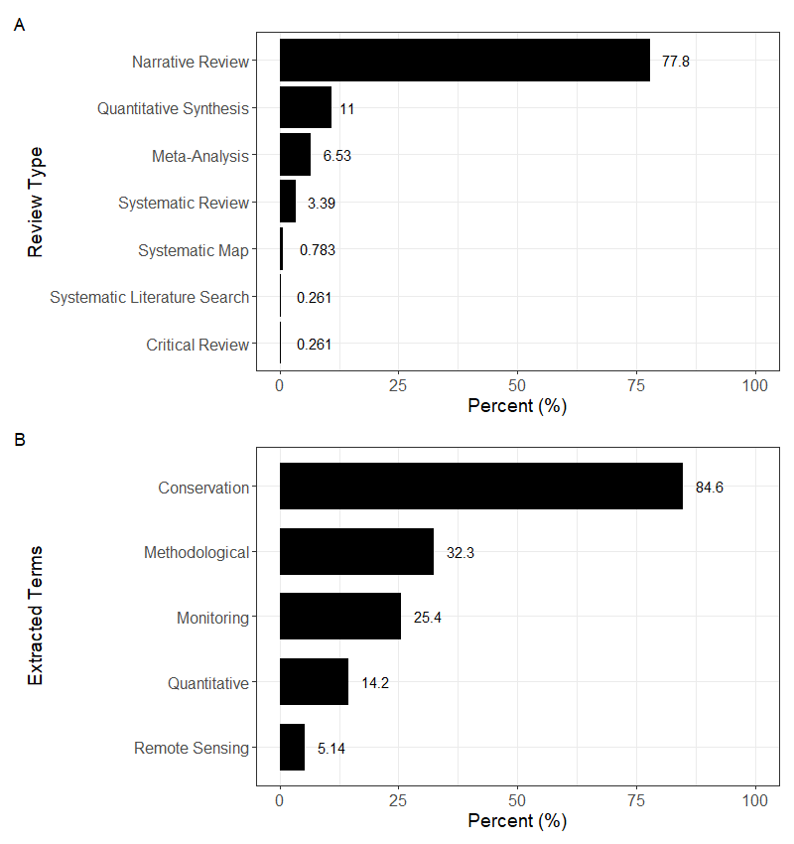

**Figure 2.** Review type and key focus termsextracted from included reviews. Plots created using the *ggplot2* package in R (version 3.4.0, Wickham, 2016). **A.** Review type of each paper as self-reported within the title, abstract, or keywords. The percentage of reviews examined that identify as a given review type are shown next to each bar. **B.** Percentage of each extracted term related to methodology as found in papers’ titles, abstracts, or keywords. Percentage of reviews that contained that term is written next to each bar. For some reviews, more than one term was relevant, so the percents do not add up to 100.

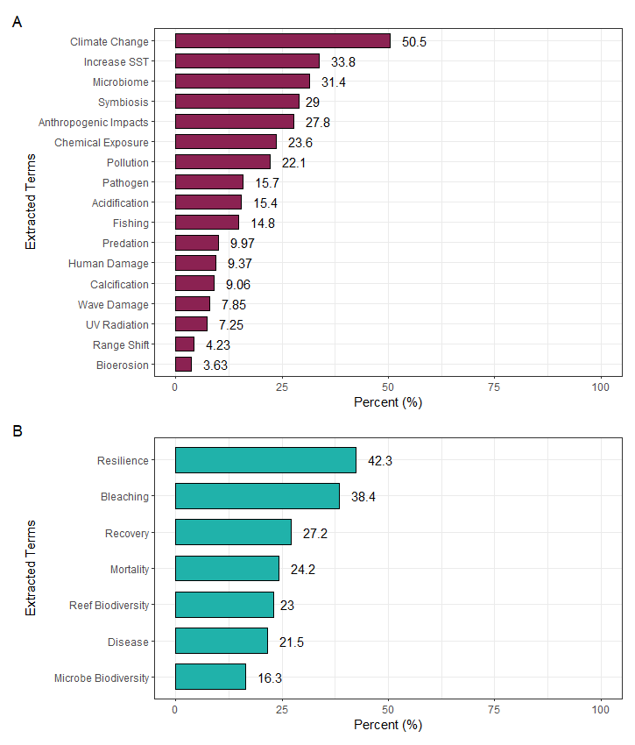

**Figure 3.** Terms extracted from papers. The percentage of each extracted term related to the drivers of coral health, as found in papers’ abstracts, titles, and keywords. Percentage of papers that contained that term is written to the right of the colored bar. For some reviews, more than one term was relevant, so the percents do not add up to 100. Plots created using *ggplot2* package in R (version 3.4.0, Wickham, 2016). **A.** Driver-related terms. Term’s presence indicated by the maroon bar. **B.** Health outcome related terms. Term’s presence indicated by the teal bar.

**Figure 4.** Author bibliometric data. **A.** Map of the reviews’ first author country affiliations visualised using the *maps* and *ggplot2* packages in R (version 3.4.1, Becker et al., 2022; version 3.4.0, Wickham, 2016). Darker blues indicate countries with more first authors of the reviews. **B.** Collaboration plot by review authors’ country affiliation created using *bibliometrix* and *circlize* R packages (version 4.1.0, Aria and Cuccurullo, 2017; version 0.4.15, Gu et al., 2014). Lines originate from one author’s country and connect the country affiliated with a collaborating author. The portion of the circumference for each country corresponds to how many authors were affiliated with that country (i.e., the more authors that are affiliated with that country, the greater the percentage of the circumference that the country occupies in the graph). Plot is colored by the presence or absence of coral reefs within the country’s territory. Countries which jointly contribute to over half of the total area of coral reefs (i.e., Australia, Indonesia, Philippines, Papua New Guinea, Fiji, and the Maldives; as stated by the Coral Reef Alliance) are colored in dark blue on the circle circumference. Countries which have a coral reef within their mainland territory but do not contribute to more than half of the world’s coral reefs (e.g., United States of America, Japan) are colored in light blue on the circle circumference. Countries which have a coral reef within their extended territory and do not contribute to more than half of the world’s coral reefs (e.g., France – New Caledonia, United Kingdom – British Virgin Islands) are colored in yellow on the circle circumference. Countries that do not have any coral reefs in their territory (e.g., Germany, Norway) are colored in light grey on the circle circumference.

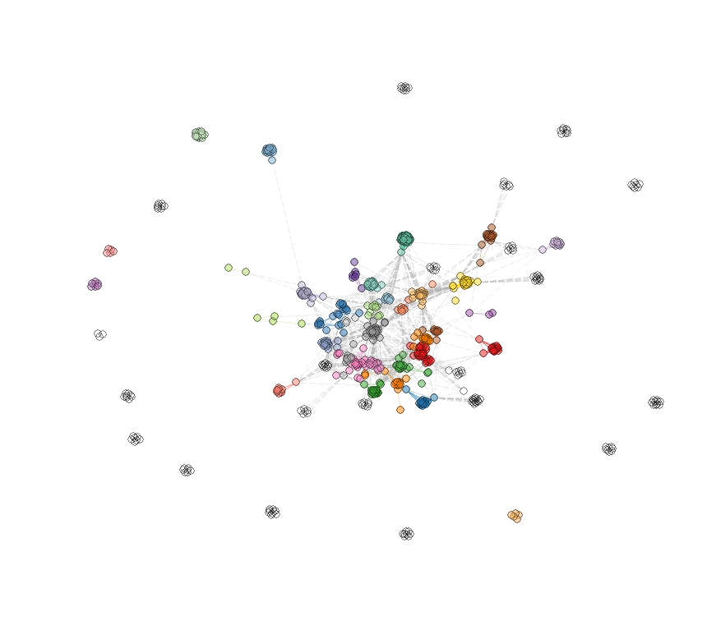

**Figure 5.** Central (largest) cluster of the author collaboration network. Each node (dot) represents an author, and edges (lines) connect authors who have collaborated on a coral health review together. Colors generally denote authors working more closely on reviews together. Network plot created using the *bibliometrix* R package (version 4.1.0, Aria and Cuccurullo, 2017).

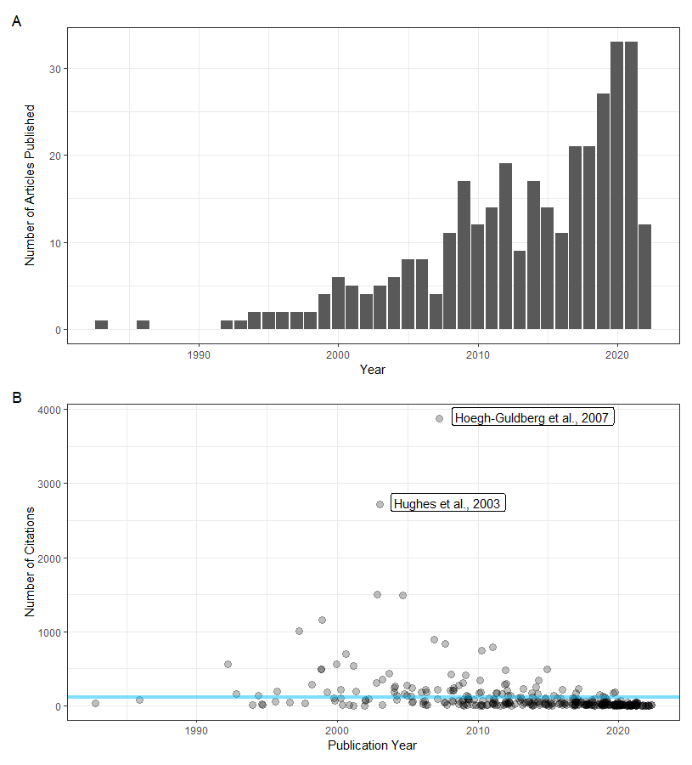

**Figure 6.** Bibliometric information plots created using R package *ggplot2* (version 3.4.0, Wickham, 2016). **A.** Counts of the collated reviews published each year. **B.** Number of citations per review plotted against the year of review publication. Blue line denotes average number of citations. Two papers that are the most extreme outliers in number of citations are labeled with their shorthand references.

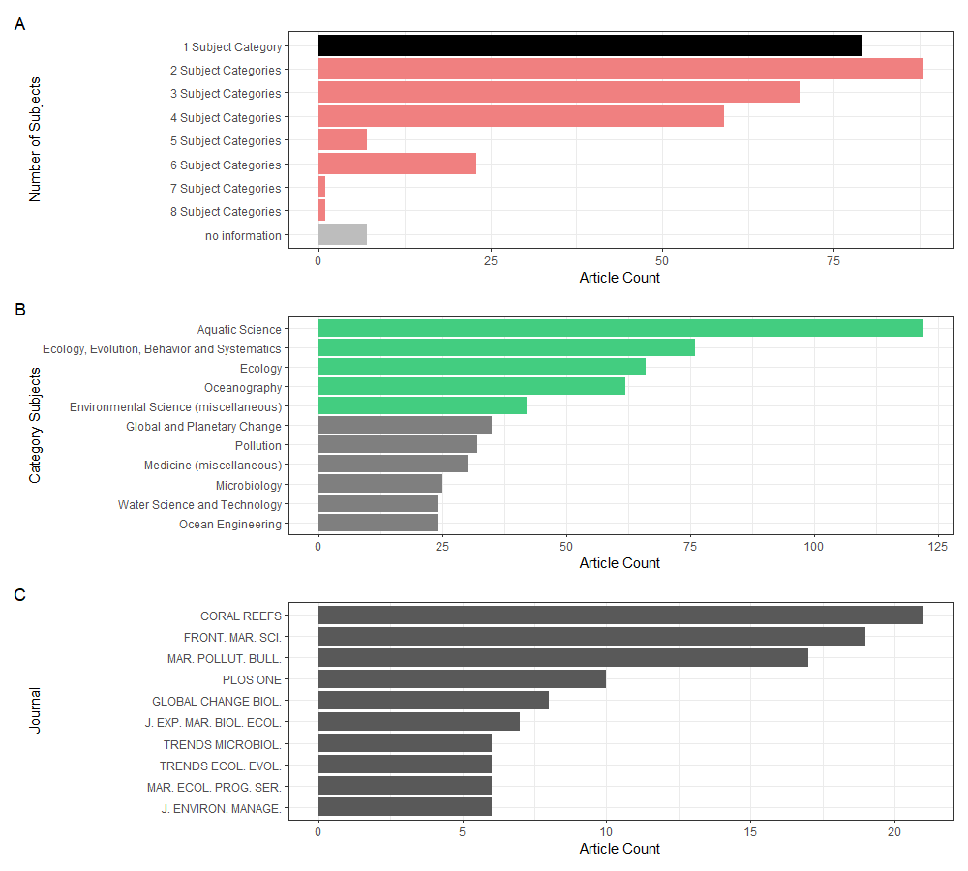

**Figure 7.** Journal information plots created using *ggplot2* R package (version 3.4.0, Wickham, 2016). **A.** Number of reviews published in specialized (one subject category in Scimago journal database – black bar) or general (more than one subject category in Scimago journal database – reddish bar) journals. **B.** Top 11 most common subject categories (“Water Science and Technology” and “Ocean Engineering” are tied for 10th most common) of journals in which coral health related reviews are published. The top five most common subject areas are especially highlighted in green as they exceed over 40 articles per subject area. The number of reviews which are published in journals of which a subject category falls into the top ten are counted for each subject category. **C.** The ten journals in which most of the reviews on coral health are published.

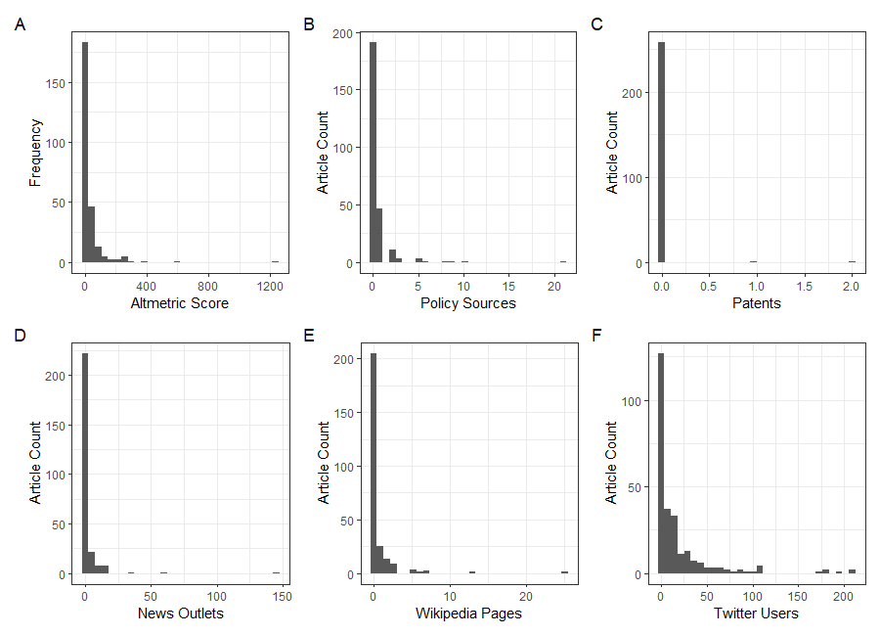

**Figure 8.** Altmetric data plots created using *ggplot2* package in R (version 3.4.0, Wickham, 2016). **A.** Distribution of total Altmetric score for coral health reviews. **B.** Distribution of citation for coral health reviews in policies. **C.** Distribution of citation for coral health reviews in patents. **D.** Distribution of citation for coral health reviews in mainstream news media. **E.** Distribution of citation for coral health reviews on Wikipedia pages. **F.** Distribution of citation for coral health reviews on Twitter.

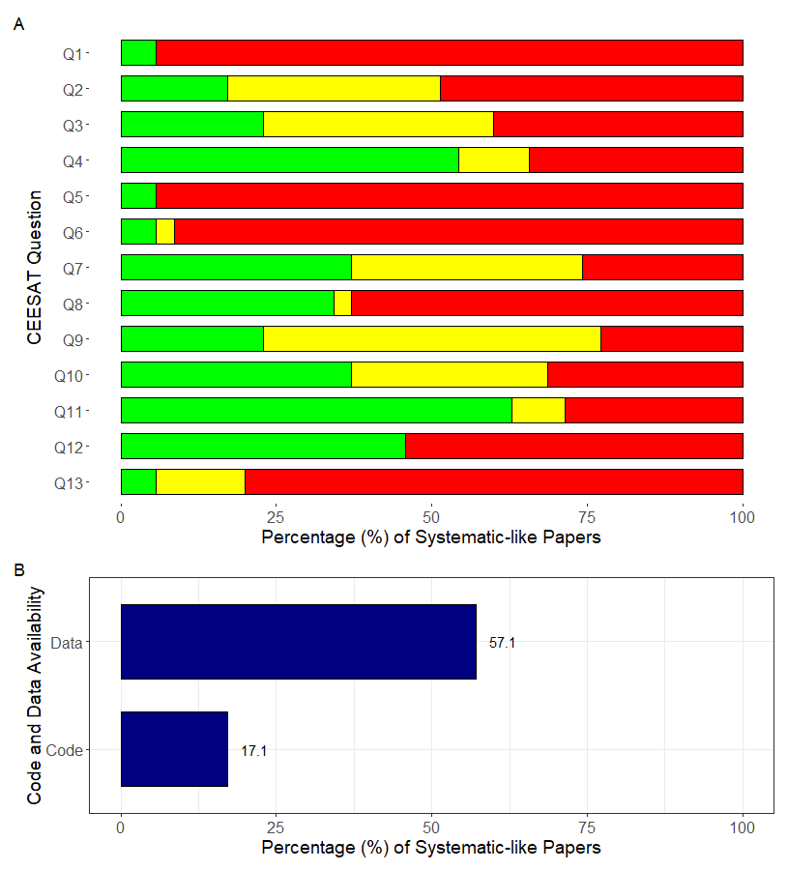

**Figure 9.** Critical Appraisal for systematic-like reviews (n = 35). Plots created using *ggplot2* R package (version 3.4.0, Wickham, 2016). **A.** Summary plot of Collaboration for Environmental Evidence Synthesis Assessment Tool (CEESAT; Woodcock et al., 2014) scores across 13 assessment questions (Q1-Q13). Reviews receive a green score when they meet the highest level of criteria (i.e., papers with the highest rigour and transparency). Reviews receive an amber score when they meet some of the criteria, but not all, or they meet a lower level of standard. Reviews receive a red score when they do not meet the criteria set out in the CEESAT assessment. **B.** Percentage of reviews that reported data and code availability.